JAVA REVIEW QUESIONS

09-09-2020.

**Submitted By,**

Tamilvanan B.

2018503566.

09-08-2020.

MO Batch.

(1) Write a java program that does a simple addition to illustrate the usage of boxing and unboxing.

**Program:**

public class box{

static void convert(int a){

Integer c = new Integer(a);

System.out.print("\nWrapper class Integer " + c);

}

public static void main(String... args) {

int a = 55;

System.out.print("Primitive data type " + a);

convert(a);

}

}

**Output:**

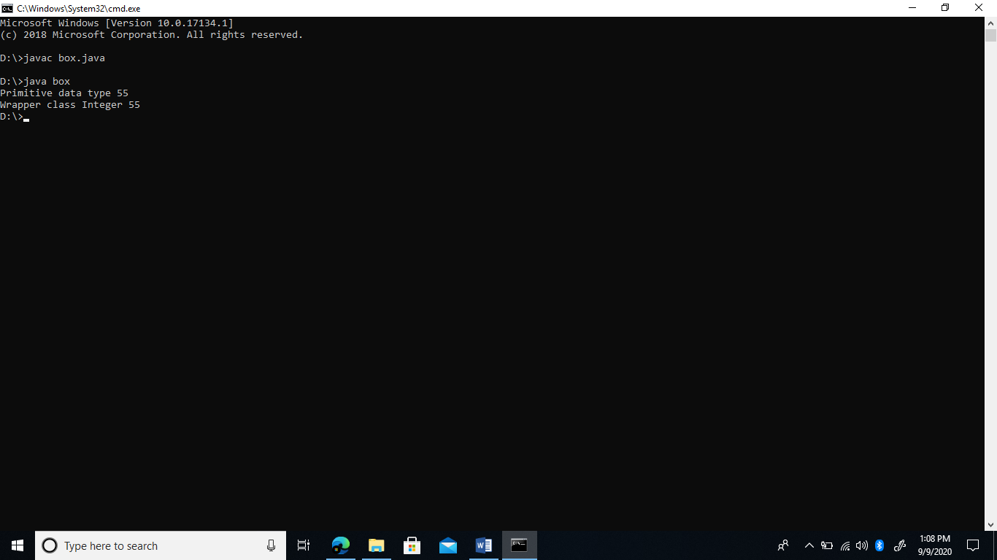

(2) Write a simple java program to illustrate boxing in method invocation.

**Program:**

public class box{

static void convert(int a){

Integer c = new Integer(a);

System.out.print("\nWrapper class Integer " + c);

}

public static void main(String... args) {

int a = 55;

System.out.print("Primitive data type " + a);

convert(a);

}

}

**Output:**

